AI Room Designer  
  
Thursday, September 11, 2025

Gaston Dana/GasMan

Open AI – Open Model H. Event

Table of Contents

AI Room Designer 3

**A Multi-Modal, Local-First AI Design Companion** 3

The "AI Orchestra": A Multi-Modal Pipeline 4

From 2D Inspiration to 3D Immersion 5

1. Project Overview & Mission 6

2. The "AI Orchestra": A Local-First, Multi-Modal Pipeline 6

3. Core Features & Technical Challenges 7

4. Setup & Full Documentation 8

# AI Room Designer

**A Multi-Modal, Local-First AI Design Companion**

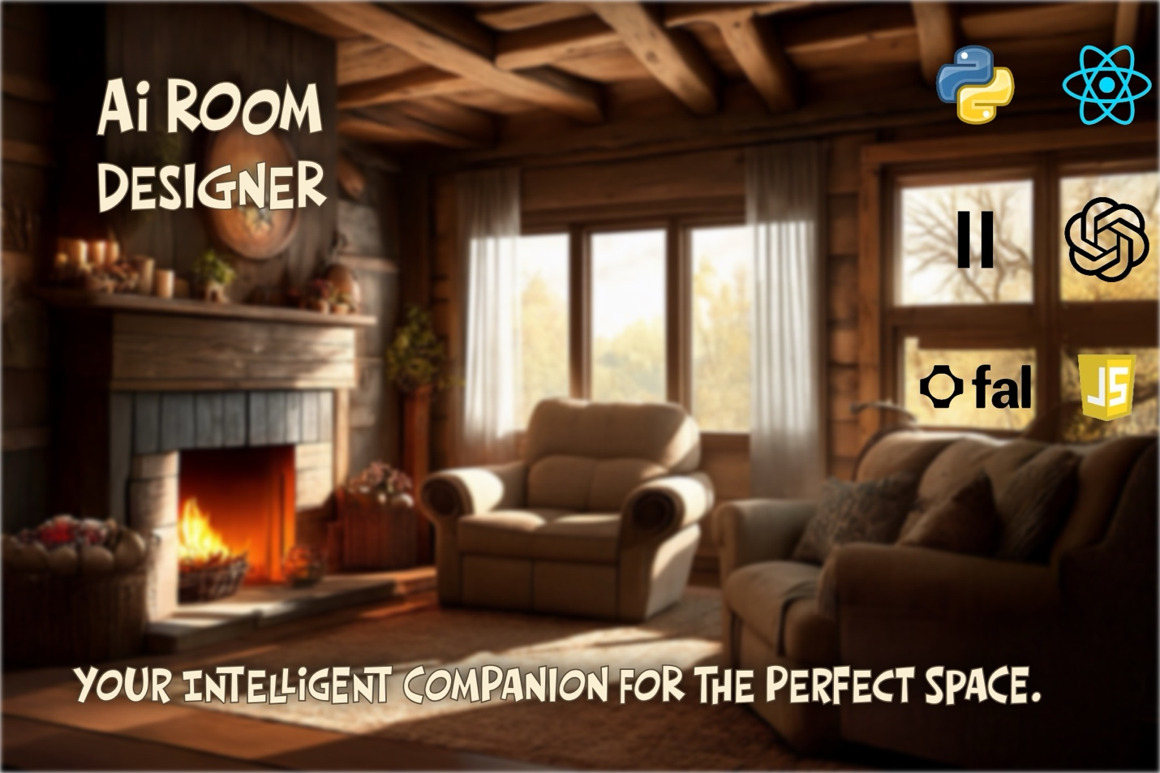   
**Created by:** Gaston Dana  
**Submission for:** The OpenAI Open Model Hackathon (September 2025)

# The "AI Orchestra": A Multi-Modal Pipeline

This project's power comes from its unique architecture. It's not just one AI; it's an entire creative team, orchestrated by a robust backend to deliver a seamless, multi-modal experience.

**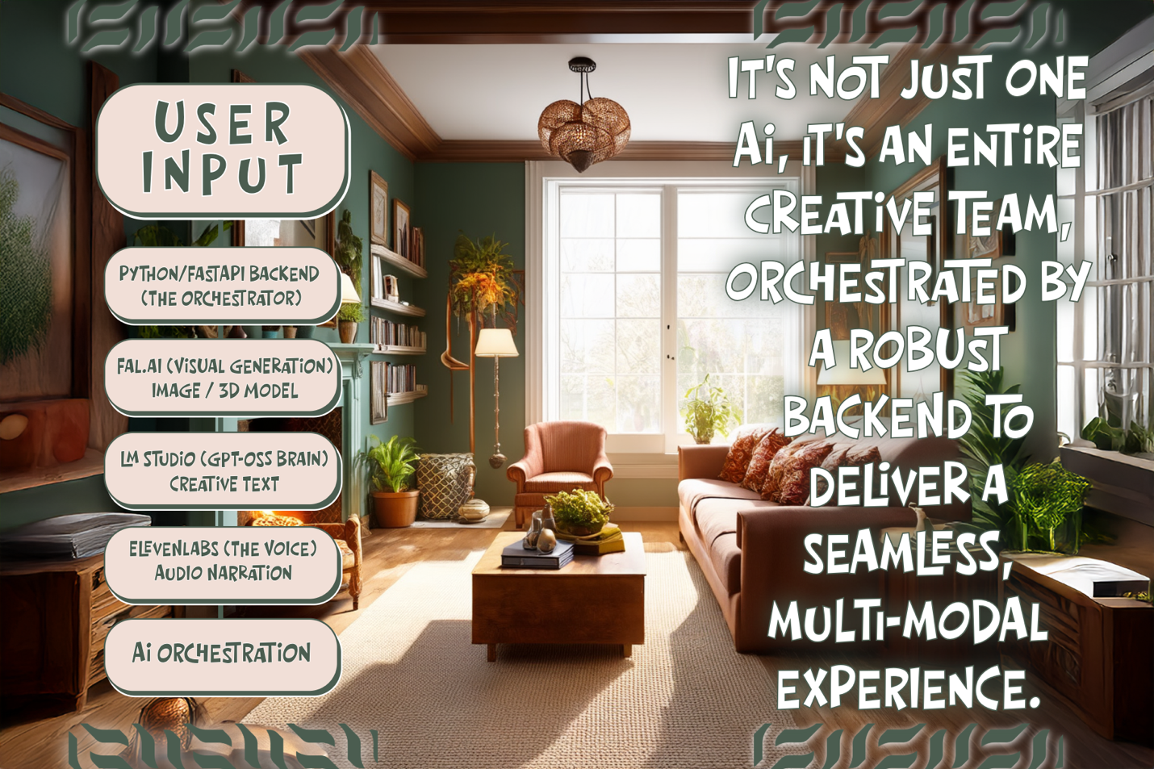  
  
  
Explanation:** This flowchart visualizes our backend-centric, local-first design.

* **The Orchestrator (Python/FastAPI):** Acts as the secure "conductor," managing all API keys and directing the workflow.
* **The Brain (gpt-oss via LM Studio):** The core intelligence, running locally to provide creative text and conversational reasoning.
* **The Artists (Fal.ai):** The powerhouse for all visual generation, handling 2D images, 3D models, and scene analysis.
* **The Voice (ElevenLabs):** The dedicated voice actor, converting the AI's text into high-quality audio.

This architecture is the key to the application's resilience and its ability to blend multiple AI capabilities into a single, cohesive user experience.

# From 2D Inspiration to 3D Immersion

The biggest technical challenge was achieving high-quality 3D reconstruction from a single photograph. The solution was the **"Ultimate Quality" 3D Pipeline**, which transforms a simple 2D image into a detailed, interactive 3D asset.

**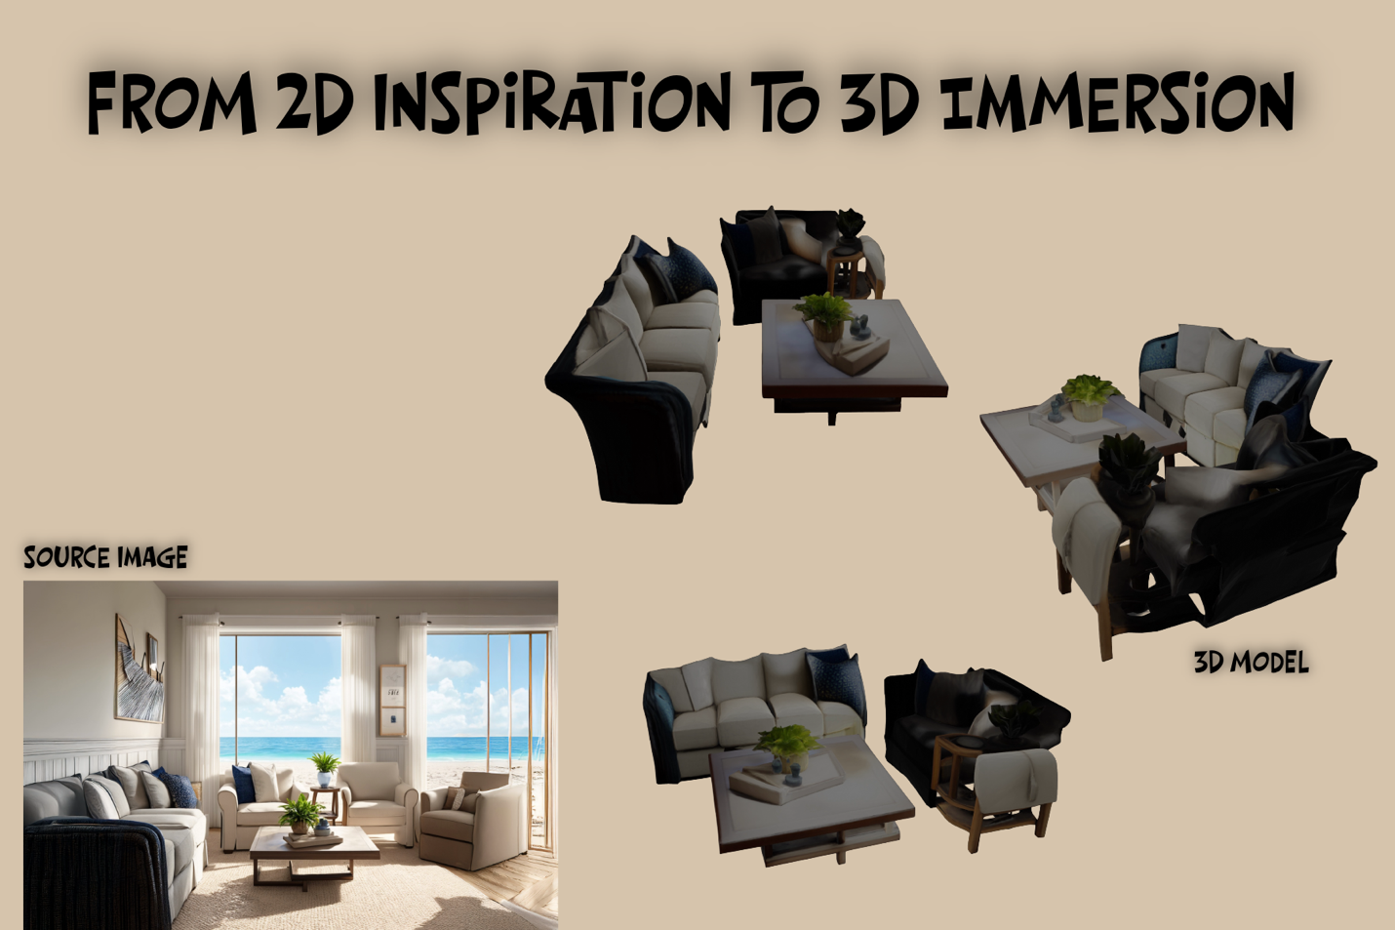  
  
Explanation:** This image demonstrates the final output of our most advanced feature.

* **The Source Image:** A single, standard 2D photorealistic image generated by the AI.
* **The 3D Model:** The final, high-fidelity .glb model produced by our multi-stage pipeline. The AI first generates 36 unique camera angles of the scene and then feeds all of them into an advanced multi-view reconstruction model (fal-ai/instant-mesh) to create a geometrically complete and richly textured result.

This is the "magic trick" at the heart of the application, turning a flat inspiration into an immersive, explorable 3D space.

# 1. Project Overview & Mission

**Mission:** To solve the "imagination gap" in interior design by creating an intelligent, multi-modal companion that empowers anyone to visualize, create, and refine their perfect space.

**[Full-width Screenshot of your Main UI Here]**

**AI Room Designer** is a full-stack application that transforms the creative process. It's not just a tool; it's a creative partner that allows users to:

* **Generate** photorealistic rooms from 36+ styles.
* **Redesign** their own space from a single photo.
* **Visualize in 3D** with an "Ultimate Quality" pipeline that creates high-fidelity, interactive 3D models.
* **Interact** with an "AI Design Consultant"—a gpt-oss powered local agent that provides dynamic, voice-driven descriptions and expert design advice.

*[For a high-level summary of the project's evolution, see the****Hackathon Ready Summary on GitHub****.]  
[* [*https://github.com/gastondana627/Rooms-Through-Time/blob/main/docs/HACKATHON_READY_SUMMARY.md*](https://github.com/gastondana627/Rooms-Through-Time/blob/main/docs/HACKATHON_READY_SUMMARY.md)*]*

# 2. The "AI Orchestra": A Local-First, Multi-Modal Pipeline

The application is built on a modern, **local-first architecture**. A powerful Python/FastAPI backend acts as a secure **AI Orchestration Engine**, managing a complex pipeline of specialized models.

**[Your "AI Orchestra" Flowchart/Infographic Here]**

This resilient design is the core of the project. Even with the Wi-Fi turned off, our gpt-oss powered "AI Design Consultant" continues to provide smart, contextual advice. When reconnected, the app seamlessly enhances the experience with high-fidelity visuals from **Fal.ai** and realistic voice narration from **ElevenLabs**.

* **gpt-oss-20b (via LM Studio):** The **local-first brain** for intelligent chat and dynamic narration.
* **Fal.ai:** The powerhouse for all **visual generation** (2D, 3D, and Segmentation).
* **ElevenLabs:** The **voice** of the AI consultant.

*[For a detailed breakdown of this architecture, see the****Local-First Philosophy on GitHub****.]  
[*[*https://github.com/gastondana627/Rooms-Through-Time/blob/main/docs/LOCAL_FIRST_PHILOSOPHY.md*](https://github.com/gastondana627/Rooms-Through-Time/blob/main/docs/LOCAL_FIRST_PHILOSOPHY.md)*]*

# 3. Core Features & Technical Challenges

**The "Ultimate Quality" 3D Pipeline**

The biggest challenge was achieving high-quality 3D reconstruction. To solve this, I implemented a multi-stage pipeline that uses AI to **generate 36 unique camera angles** from a single photo before feeding them into an advanced multi-view 3D model.

**[Your "3D Showcase" Side-by-Side Image Here]**

*[For a complete technical breakdown of this pipeline, see the****Ultra 3D Improvements Guide on GitHub****.]  
[*[*https://github.com/gastondana627/Rooms-Through-Time/blob/main/docs/ULTRA_3D_IMPROVEMENTS.md*](https://github.com/gastondana627/Rooms-Through-Time/blob/main/docs/ULTRA_3D_IMPROVEMENTS.md)*]*

**The gpt-oss "Soul"**

The gpt-oss-20b model is the "soul" of the app. Running entirely offline via LM Studio, it powers the interactive character, allowing for expert design advice and creative conversation.

*[For a full guide on the character system, see the****Character Interaction System docs on GitHub****.]  
[*[*https://github.com/gastondana627/Rooms-Through-Time/blob/main/docs/CHARACTER_INTERACTION_SYSTEM.md*](https://github.com/gastondana627/Rooms-Through-Time/blob/main/docs/CHARACTER_INTERACTION_SYSTEM.md)*]*

**Overcoming Real-World Hurdles**

This project was a marathon of problem-solving, from sudden API billing walls to evolving model endpoints. Each challenge was met with a robust architectural solution, resulting in a resilient and stable final product.

*[For a complete list of issues and their solutions, see the****Fixes Applied documentation on GitHub****.]  
[*[*https://github.com/gastondana627/Rooms-Through-Time/blob/main/docs/FIXES_APPLIED.md*](https://github.com/gastondana627/Rooms-Through-Time/blob/main/docs/FIXES_APPLIED.md)*]*

# 4. Setup & Full Documentation

This project is built to be run and tested locally. The following guides provide everything needed to get started.

* **[Deployment Guide & Testing Instructions]  
  [**[**https://github.com/gastondana627/Rooms-Through-Time/blob/main/docs/DEPLOYMENT_GUIDE.md**](https://github.com/gastondana627/Rooms-Through-Time/blob/main/docs/DEPLOYMENT_GUIDE.md)**]**
* **[LM Studio & Local-First Setup]  
  [**[**https://github.com/gastondana627/Rooms-Through-Time/blob/main/docs/LM_STUDIO_SETUP.md**](https://github.com/gastondana627/Rooms-Through-Time/blob/main/docs/LM_STUDIO_SETUP.md)**]**
* **[Style & Mascot Reference]  
  [**[**https://github.com/gastondana627/Rooms-Through-Time/blob/main/docs/ELEGANT_MASCOT_BREEDS.md**](https://github.com/gastondana627/Rooms-Through-Time/blob/main/docs/ELEGANT_MASCOT_BREEDS.md)**]**